CHAPTER 8
6. The following are historic returns for the Chelle Computer Company.
Year Chelle General Index
1 37 15
2 9 13
3 -11 14
4 8 -9
5 11 12
6 4 9
Based on this information, compute the following:
- The correlation coefficient between Chelle Computer and the General Index.
- The standard deviation for the company and the index.
- The beta for the Chelle Computer Company
8. As an equity analyst, you have developed the following return forecasts and risk estimates for two different stock mutual funds (Fund T and Fund U):
Forecasted Return CAPM Beta
Fund T 9.0% 1.20
Fund U 10.0 0.80
- If the risk-free rate is 3.9 percent and the expected market risk premium (i.e., E(RM) – RFR) is 6.1 percent, calculate the expected return for each mutual fund according to the CAPM.
- Using the expected returns from Part a along with your own return forecasts, demonstrate whether Fund T and Fund U are currently priced to fall directly on the security market line (SML), or below the SML.
- According to your analysis, are Funds T and U overvalued, undervalued, or properly valued?
10. Draw the security market line for each of the following conditions:
- (1) RFR = 0.08; RM (proxy) = 0.12
(2) RZ = 0.06; RM (true) = 0.15
- Rader Tire has the following results for the last six periods. Calculate and compare the beats using each index.
RATES OF RETURN
Rader Tire Proxy Specific Index True General Index
Period (%) (%) (%)
1 29 12 15
2 12 10 13
3 -12 -9 -8
4 17 14 18
5 20 25 28
6 -5 -10 0
- If the current period for the market is 12 percent and for Radar Tire it is 11 percent, are superior results being obtained for either index beta?
CHAPTER 9
3. You have bee assigned the task of estimating the expected returns for three different stocks: QRS, TUV, and WXY. Your preliminary analysis has established the historical risk premiums associated with three risk factors that could potentially be included in your calculations: the excess return on a proxy for the market portfolio (MKT), and two variables capturing general macroeconomics exposures (MACRO1 and MACRO2). These values are λMKT = 7.5%, λ MACRO2= 0.6%. You have also estimated the following factor betas (i.e., loadings) for all three stocks with respect to each of these potential risk facors:
FACTOR LOADING
Stock MKT MACRO1 MACRO2
QRS 1.24 -0.42 0.00
TUV 0.91 0.54 0.23
WXY 1.03 -0.09 0.00
- Calculate expected returns for the three stocks using just the MKT risk factor. Assume a risk-free rate of 4.5%.
- Calculate the expected returns for the three stocks using all three risk factors and the same 4.5% risk-free rate,
- Discuss the differences between the expected return estimates from the single-factor model and those from the multifactor model. Which estimates are most likely to be more useful in practice?
- What sort of exposure might MACRO2 represent? Given the estimated factor betas, is it really reasonable to consider it a common (i.e., systematic) risk factor?
5. Suppose that three stocks (A, B, and C) and two common risk factors (1 and 2) have the following relationship:
E(RA ) = (1.1)λ1 + (0.8)λ2
E(RB) = (0.7)λ1 + (0.6)λ2
E(RC) = (0.3)λ1 + (0.4)λ2
- If λ1 = 4% and λ2 = 2%, what are the prices expected next year for each of the stocks? Assume that all three stocks currently sell for $30 and will not pay a dividend in the next year.
- Suppose that you know that next year the prices for Stocks A, B, and C will actually be $31.50, $35.00, and $30.50. Create and demonstrate a riskless, arbitrage investment to take advantage of these priced securities. What is the profit from your investment? You may assume that you can use the proceeds from any necessary short sale.
7. a. Using regression analysis, calculate the factor betas of each stock associated with each of the common risk factors. Which of these coefficients are statistically significant?
b. How well does the factor model explain the variation in portfolio returns? On what basis can you make an evaluation of this nature?
c. Suppose you are now told that the three factors in Exhibit 9.12 represent the risk exposures in the Fama-French characteristic-based model (i.e., excess market, SMB, and HML.) Based on your regression results, which one of these factors is the most likely to be the market factor? Explain why.
d. Suppose it is further revealed that Factor 3 is the HML factor. Which of the two portfolios is most likely to be a growth-oriented fund and which is a value-oriented fund? Explain why.
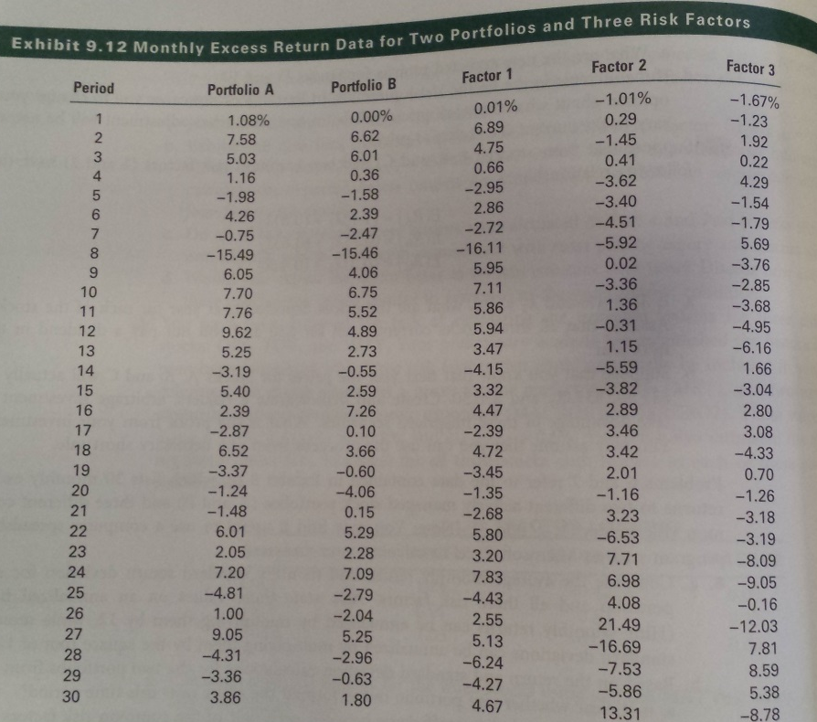

CHAPTER 10
4. (Question 4 is composed of two parts.) The DuPont formula defines the net return on shareholder’s equity as a function of the following components:
- Operating margin
- Asset turnover
- Interest burden
- Financial leverage
- Income tax rate
Using only the data in the following table shown below:
- Calculate each of the five components listed above for 2010 and 2014, and calculate the return on equity (ROE) for 2010 and 2014, using all of the five components. Show calculations.
- Briefly discuss the impact of the changes in asset turnover and financial leverage on the change in ROE from 2010 to 2014.
Income Statement Data 2010 2014
Revenues $542 $979
Operating income 38 76
Depreciation and amortization 3 9
Interest expense 3 0
Pretax income 32 67
Income taxes 13 37
Net income after tax 1 9 30
Balance Sheet Data 2010 2014
Fixed assets $41 $70
Total assets 245 291
Working capital 123 157
Total debt 16 0
Total shareholder’s equity 159 220
5. David Wright, CFA, an analyst with Blue River Investments, is considering buying a Montrose Cable Company corporate bond. He has collected the following balance sheet and income statement information for Montrose as shown in Exhibit 10.10. He has also calculated the three ratios shown in Exhibit 10.11, which indicate the bond that is currently rated “A” according to the firm’s internal bond-rating criteria shown in Exhibit 10.13. Wright has decided to consider some off-balance sheet items in his credit analysis, as the off-balance sheet items on each of the ratios found in Exhibit 10.11.
- Calculate the combined effect of the three off-balance sheet items in Exhibit 10.12 on each of the following three financial ratios shown in Exhibit 10.11.
i. EBITDA/interest expense
ii. Long/term debt/equity
iii. Current assets/current liabilities
The bond is currently trading at a credit premium off 55 basis points. Using the internal credit yield premium incorporates the effect of the off-balance sheet items.
- State and justify whether or not the current credit yield premium compensates Wright for the credit risk of the bond based on the internal-bond rating criteria found in Exhibit 10.13.
Exhibit 10.10 Montrose Cable Company Year Ended March 31, 2011
(US$ Thousands)
Balance Sheet
Current assets $4,735
Fixed assets 43,225
Total assets $47,960
Current liabilities $4,500
Long-term debt 10,000
Total liabilities $14,500
Shareholder’s equity 33,460
Total liabilities and shareholder’s equity $47,960

Income Statement
Revenue $18,500
Operating and administrative expenses 14,050
Operating income $4,450
Depreciation and amortization 1,675
Interest expense 942
Income before income taxes $1,833
Taxes 641
Net Income $1,192
Exhibit 10.11 Selected Ratios and Credit Yield Premium Data for Montrose
EBITDA/interest expense 4.72
Long-term debt/equity 0.30
Current assets/current liabilities 1.05
Credit yield premium over U.S. Treasuries 55 basis points
Exhibit 10.12 Montrose Off | Balance | Sheet Items
- Montrose has guaranteed the long-term debt (principal only) of an unconsolidated affiliate. This obligation has a present value of $995,000.
- Montrose has sold $500,000 of accounts receivable with recourse at a yield of 8 percent
- Montrose is a lessee in a new noncancelable operating leasing agreement to finance transmission equipment. The discounted present value of the lease payments is $6,144,000 using an interest rate of 10 percent. The annual payment will be 1,000,000.
Exhibit 10.13 Blue River Investments: Internal Bond | Rating Criteria and Credit Yield Premium Data
Bond Rating | Interest Coverage  (EBITDA/interest expense) | Leverage | Current Ratio (Current assets/current liabilities) | Credit Yield Premium over U.S. Treasuries  (in basis points)
AA 5.00 to 6.00 0.25 to 0.30 1.15 to 1.25 30 bps
A 4.00 to 5.00 0.30 to 0.40 1.00 to 1.15 50bps
BBB 3.00 to 4.00 0.40 to 0.50 0.90 to 1.00 100bps
BB 2.00 to 3.00 0.50 to 0.60 0.75 to 0.90 125bps
Chapter 11
6. Over the long run, you expect dividends for BBC in Problem 4 to grow at 8 percent and you require 11 percent on the stock. Using the infinite period DDM, how much would you pay for this stock?
8. The Shamrock Dogfood Company (SDC) has consistently paid out 40 percent of its earnings in dividends. The company’s return on equity is 16 percent. What would you estimate as itsi dividend growth rate?
10. What P/E ratio would you apply if you learned that SDC had decided to increase its payout to 50 percent? (Hint: This change in payout has multiple effects.)
Chapter 12
4. Currently, the dividend=payout ratio (D/E) for the aggregate market is 60 percent, the required return (k) is 11 percent, and the expected growth rate for dividends (g) is 5 percent.
- Compute the current earnings multiplier
- You expect the D/E payout ratio to decline to 50 percent, but you assume there will be no other changes. What will be the P/E?
- Starting with the initial conditions, you expect the dividend-payout ratio to be constant. The rate of inflation to increase by 3 percent and the growth rate to increase by 2 percent. Compute the expected P/E.
- Starting with the initial conditions, you expect the dividend-payout ratio to be constant, the rate of inflation to decline by 3 percent, and the growth rate to decline by 1 percent. Compute the expected P/E.
7. Given the three EPS estimates in Problem 6, you are also given the following estimates related to the market earnings multiple:
Pessimistic Consensus Optimistic
D/E 0.65 0.55 0.45
Nominal RFR 0.10 0.09 0.08
Risk premium 0.05 0.04 0.03
ROE 0.11 0.13 0.15
- Based on the three EPS and P/E estimates, compute the high, low, and consensus intrinsic market value for the S&P Industrials Index in 2013.
- Assuming that the S&P Industrials Index at the beginning of the year was priced at 2.050, compute your estimated rate of return under three scenarios from Part a. Assuming your required rate of return is equal to the consensus, how would you weigh the S&P Industrials Index in your global portfolio?
8. You are analyzing the U.S. equity market based upon the S&P Industrials Index and using the present value of free cash flow to equity technique. Your inputs are as follows:
Beginning FCFE: $80
K = 0.09
Growth Rate:
Year 1-3: 9%
4-6: 8%
7 and beyond: 7%
- Assuming that the current value for the S&P Industrials Index is 2,050, would you underweight, overweight, or market weight the U.S. equity market?
- Assume that there is a 1 percent increase in the rate of inflation — what would be the market’s value, and how would you weigh the U.S. market? State your assumptions.
CHAPTER 13
4. Evaluate your industry in terms of the five factors that determine an industry’s intensity of competition. Based on this analysis, what are your expectations about the industry’s profitability in the short run (1 or 2 years) and the long run (5 to 10 years)?
5. Using Standard and Poor’s Analysts’ Handbook or another source, plot the latest 10-year history of the operating profit margin for the S&P Industrials Index, or another aggregate market series versus and industry of your choice. Is there positive, negative, or zero correlation?
7. Prepare a table listing the variables that influence the earnings multiplier for your chosen industry and the market index series for the most recent 10 years.
- Do the average dividend-payout ratios for your industry and market index differ? How should the dividend payout influence the difference between the multipliers?
- Based on the fundamental factors, would you expect the risk for this industry to differ from that for the market? In what direction, and why? Calculate the industry beta using monthly data for five years. Based on the fundamental factors and the computed systematic risk, how does this industry’s risk compare to the market? What effect will this difference in risk have on the industry’s multiplier relative to the market multiplier?
- Analyze and discuss the different components of growth (retention rate, total asset turnover, total assets/equity, and profit margin) for your chosen industry and a market index during the most recent 10 years. Based on this analysis, how would you expect the growth rate for your industry to compare with the growth rate for the market index? How would this difference in expected growth affect the multiplier?

Discussion
- Determine whether a steel company or a retail food chain would have a greater business risk. Provide support for your rationale.
- Select one of the limitations of ratio analysis and indicate why you believe it is a major concern when predicting future financial performance.
- Discuss the proposition that differences in the performance of various firms within an industry limit the usefulness of industry analysis. Provide an example of an industry where this statement holds true.
- Analyze an industry that you believe is in stage 2 of the industry life cycle. Provide evidence that supports your analysis.
- From the e-Activity and based on the growth company selected, assess why it is a growth stock and if that status is sustainable.
- Evaluate whether or not P/E is an effective indicator of a growth stock. Suggest an alternative.
- Assess the gaps with the availability of information related to international markets, industries, and stocks. Recommended a strategy for investment professionals to analyze foreign markets given the data limitations.
- Discuss how foreign countries’ accounting differences make foreign analysis difficult and whether or not adopting a global accounting standard will elevate this difficulty. Provide support for your answer.

